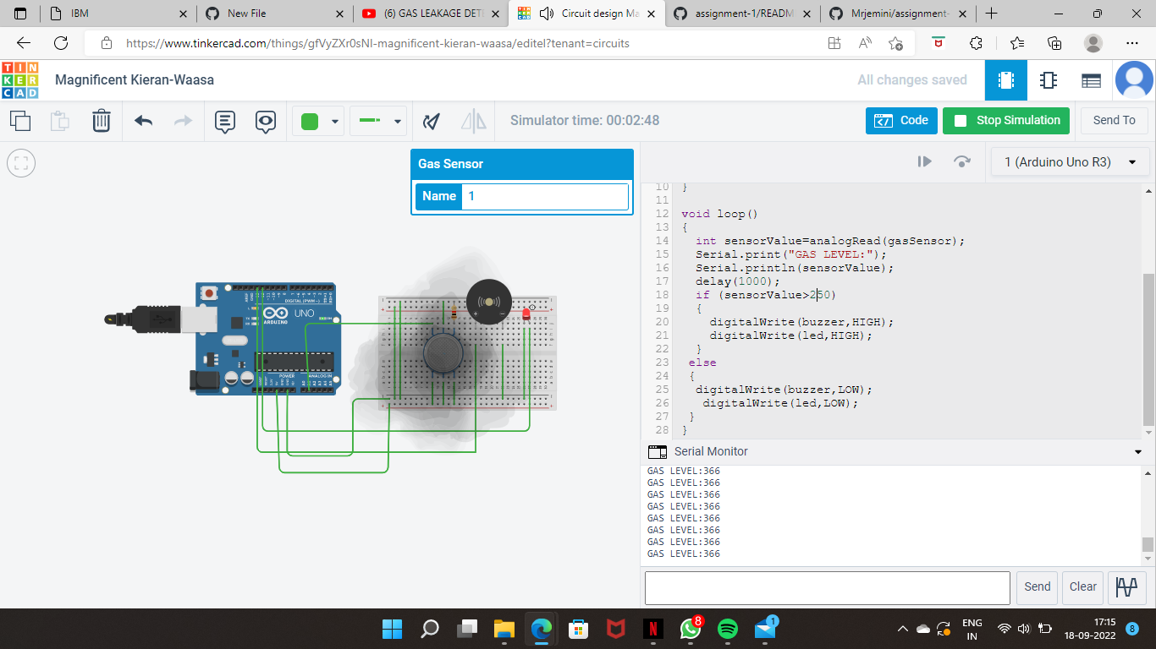

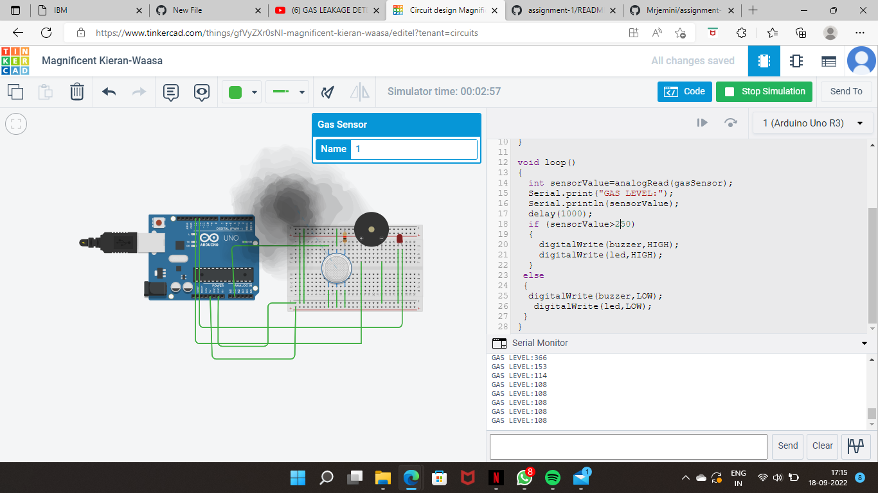

Tinkercad link: https://www.tinkercad.com/things/gfVyZXr0sNl-magnificent-kieran-waasa/editel?sharecode=VME-iz0yKt61nj93VD4nl6RHgD7o1vPbqDTPySBtwEM